CIVE 450
Water and Wastewater
Treatment

Water Treatment

- Introduction to water treatment
- Water treatment processes
- Storage
- Screening
- Sedimentation
- Coagulation/Flocculation
- Filtration
- Miscellaneous treatment processes

Introduction

The objectives of water ad wastewater treatment lie in the removal of water-laden impurities in order to render them fit for use, re-use or disposal without inducing negative impacts on health or the environment.

The type and extent of treatment will depend on the type of impurities present in the water and the ultimate use of the water.

Condensation of water takes place on a particle of dust, thus water gets polluted as soon as it is formed. As water comes down (rain), it picks gases, dust, bacteria, viruses, etc… So by the time water reaches the ground it is polluted. As water moves on the ground it picks up more and more pollutants (mostly suspended solids and this is why water in a river is not clear). When water on the other hand seeps into the ground, suspended solids are filtered and minerals are induced in the water (this is why groundwater is crystal clear)…
…So the difference between surface water and ground water is that ground water is filtered out… suspended particle are removed but minerals are induced.
Normally (in conventional water treatment) we do not remove minerals from water (we mostly remove particles that we can see), unless water is needed for a specific purpose… So in other words we can say that we undertake specific treatment for specific objective/purpose or ultimate use of the water.
In both cases (whether we have ground or surface water), even if the water is crystal clear we always disinfect the water from bacteria. (Remember that we treat the water according to its ultimate use; so even if we dispose of that water we should make sure that it doesn’t harm the environment).
Ultimate use: what we will use the water for.

Impurities in water are formed in different forms which are divided into solids or dissolved organic and inorganic materials as well as living microorganisms some of which are harmful while others are beneficial.

Impurities are classified as:
Physical – Chemical – Biological – Radiological and are mostly expresses in terms of units of mass per unit volume.

Physical Impurities: They can be determined through senses (taste, smell, look, etc…)

Chemical Impurities: Dissolved impurities, which can not be seen (unless they have a color) but they can be smelled.

Biological Impurities: Some can be detected like worms; others can not be detected like bacteria or viruses. This is why we should always disinfect the water to make sure that we have no bacteria or viruses.

Radiological Impurities: Water can be polluted by radio active wastes or natural sources found sometimes underground.

All impurities are expressed in mass per unit volume (mg/l).

Impurities in water
Classification by Type

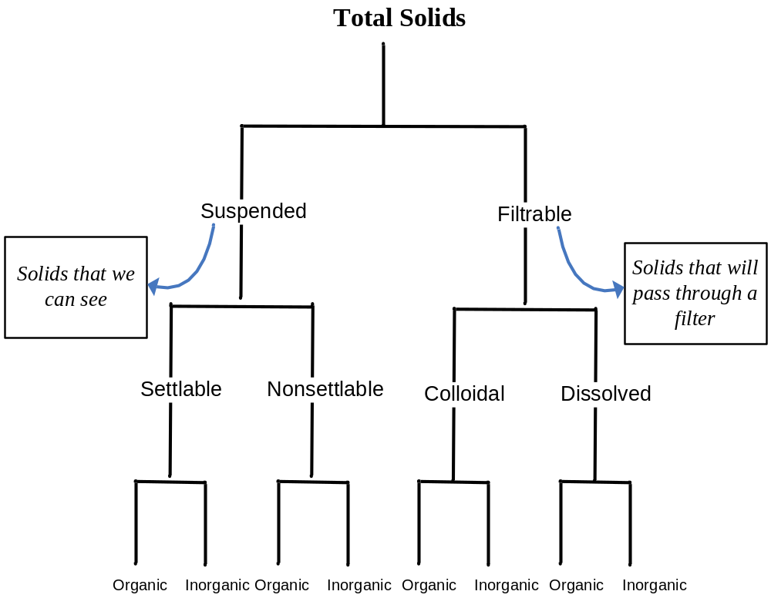
Water is referred to as contaminated (polluted) when it contains materials which render it unsuitable for its intended use.

Classification of impurities by size

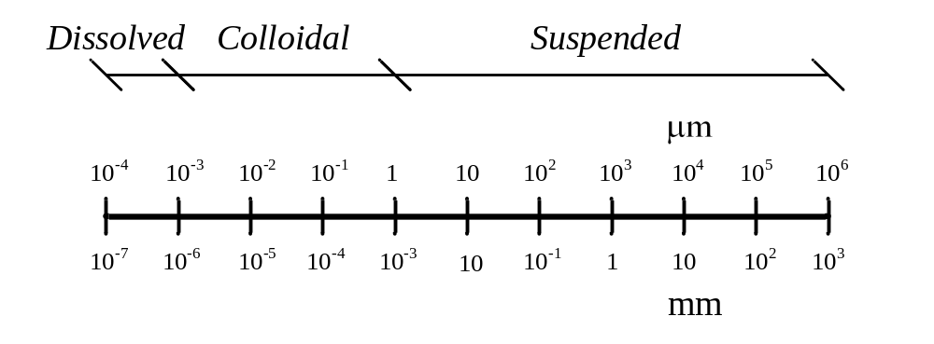
Contaminated water (or polluted water): water that contains certain materials unfit or unsuitable for use (depending on the use).

Conventional Water Treatment
(The picture is on the next page)

- Screening: The processes in which large particles are removed, spaces between the bars of a screen are about 2.5-7.5cm.
- Primary settling tank: All settlable particles settle in this tank, settlable particles are all the particles that will settle in the tank if left for 2 hours (particles that need more than 2 hours are nonsettlable). In this process we normally remove inorganic clay particles from the water. (Colloidal particles will never settle out)
- Coagulation/Flocculation: Coagulation is a chemical process where we add some additives (material) to water which will help in the coagulation of the nonsettlable particles. Flocculation is a physical process (mixing), which helps in the agglomeration of these particles into larger particles. After the coagulation/flocculation water moves to a secondary settling tank…
- Filtration: Some particles will not coagulate and will not be large enough to settle, so we then go to another process which is filtration to remove particles which were not removed in the previous processes.
- Disinfection: After filtration water will be crystal clear, however the turbidity will be around 0.1 to 0.2(nothing to worry about), which means that it might have some bacteria and microorganisms. This is why we add some chemicals to disinfect the water.
We measure the turbidity of water by passing a light beam through a sample of this
water; if the water is turbid then some of the light will be diffracted…
The sludge which we collect is not harmful; it’s mostly clay so it doesn’t need to be
treated and we can throw it anywhere.

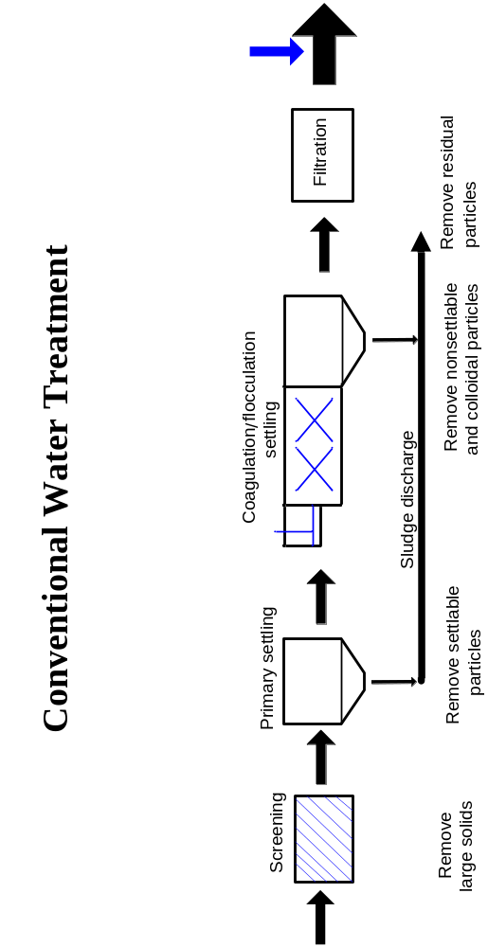
Storage

Storage may be classified as a treatment process because of its effect on the quality of water. It is reported that long results in reduction in the turbidity and bacterial content particularly pathogenic (90% die off in 5-7 days storage, others require weeks for destruction).

Under favorable conditions, storage may permit the use of stored water with no other treatment than disinfection.

Open storage is undesirable because of algal growth which might create odors.

Pathogenic bacteria: (harmful bacteria), these bacteria are very susceptible to change of environment; they live in a specific area, if changed this may kill them (this is why a settling tank can cause the death of these bacteria). For example E-coli is a type of bacteria that lives in the stomach and intestine, but if it accidentally goes through the urinary track it’ll cause a disease that may kill a person. (They will produce toxins that will make a person very sick and it’ll need very strong antibiotic to treat it). Another example is bacteria that are present in the tonsils which will die once removed from their place.
One way or another there is no clean storage; if the storage is exposed to sunlight, algae might grow (it’ll pollute the water). Some algae are toxic…Moreover it might create odor and smell.

Screens

Screens are used to remove relatively large objects that are suspended or floating in the water.

Screens are placed at water intakes, inlets to pumping stations and inlets to water or sewage treatment plants.

Screens are classified by mode of operation into fixed screens and mechanical screens and by size of opening into fine (bars are about 4mm apart), medium, and coarse screens. (Fine screens are used when you have relatively clean water)

Fixed screens are normally made at flat steel bars (10 mm x 40 mm section) with spacing of 2.5 to 7.5 cm, placed either vertically or at a slight slope from the vertical.

After storage we go through the screening process, it is better to place the screens in an inclined state because they are easier to clean.

Clear openings should have sufficient area so that the velocity through them will not be over 0.9-1.0 m/sec. The approach velocity is normally between 0.3 and 0.6 m/sec.

Head loss is normally about 15 cm.
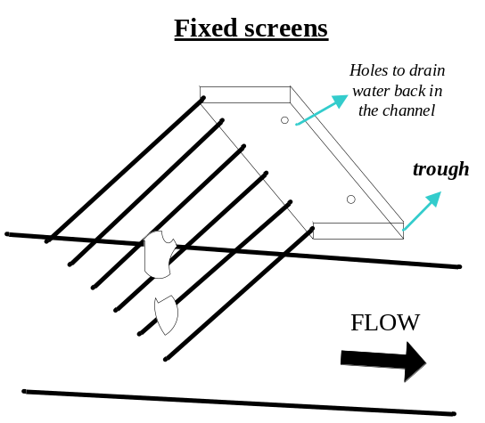

Fixed screens: are a group of bars that are placed in a channel and are fixed there. To clean the screens, we use a fork shaped bar to clean the bars by moving the stuck material upward.

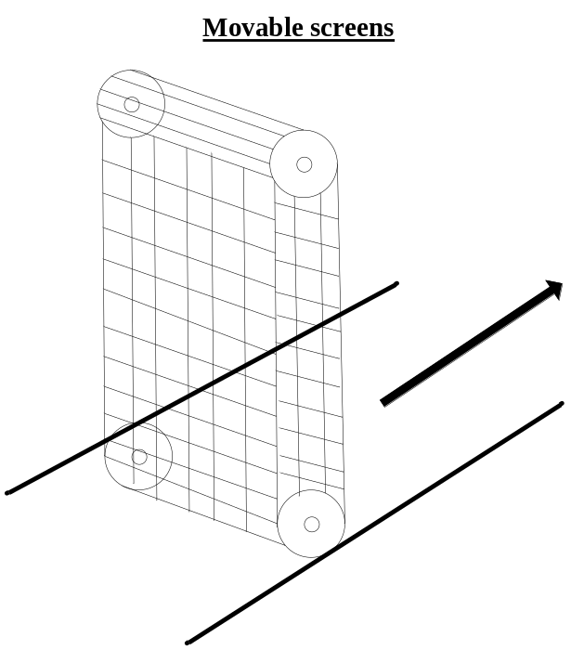

Movable screens: These screens works as follows… when the mesh rotates, wastes are taken up to a trough (similar to the one used in the fixed screens), such that it’s open edge is facing the mesh.
The drop in the level of water after the screen shows that we have a head loss which is created by the screen (the head loss will increase more if the screen is not clean… if the head loss is about 15cms then the screens are relatively clean, but if the head loss reaches 30cms, clean the screens). The velocity of water will prevent any settling, also at the screen the velocity will be greater than the approach velocity due to the reduction of the cross sectional area at the bars… (The approach velocity will be approximately between 0.5 to 0.6 m/s while it’ll be around 0.9m/s at the screens).

Sedimentation
(Settling or clarification)

Sedimentation is a physical process used in the separation of solid particles from the liquid phase.

A particle in still fluid of less density will move vertically downward because of gravity. It will accelerate until the frictional resistance of the fluid approaches the impelling force, and thereafter the vertical velocity will remain constant.

Final velocity is known as the settling velocity.

Selltable, suspended, inorganic solids are removed in primary settling. Particles in the water will only accelerate for few cms of settling… then the particles in the water will move at a constant velocity (the settling velocity)…

Types of sedimentation

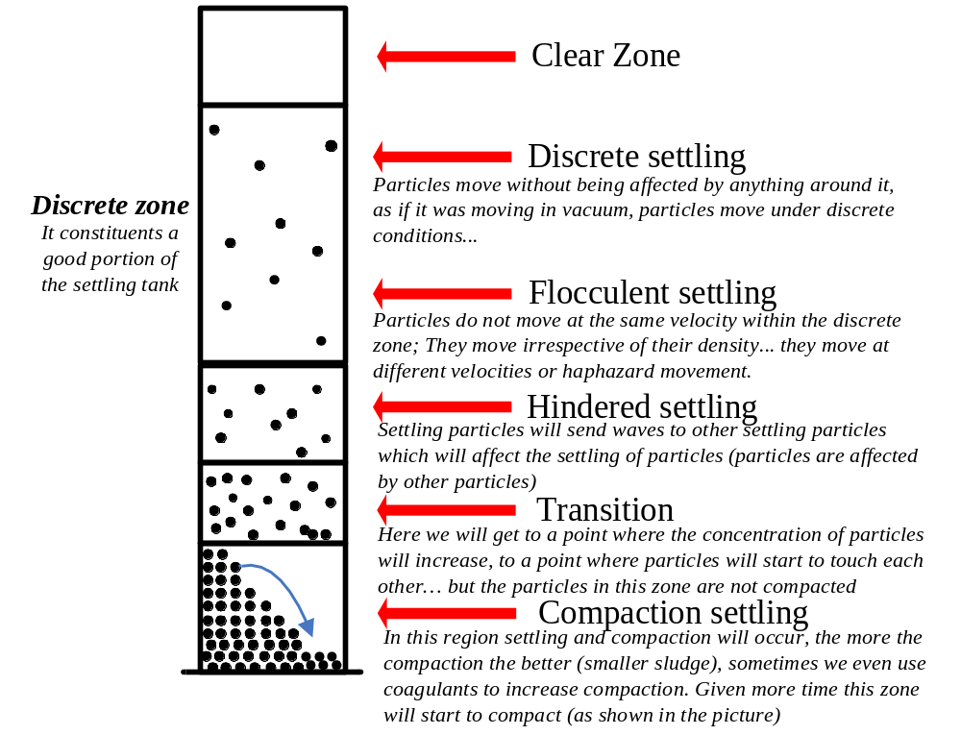
Discrete settling | Refers to the sedimentation of particles in a suspension of low solids concentration. Particles as individual entities with no interaction | Removes grit and sand particles
Flocculent settling | Refers to a rather dilute suspension of particles that coalesce or flocculate while settling. Mass builds up & settles at a faster rate | Removes a portion of the suspended solids in primary settling and in upper portion of secondary settling facilities
Hindered settling | Refers to suspensions of intermediate concentration, in which inter-particle forces are sufficient to hinder the settling of neighboring ones | Occurs in secondary settling used in conjunction with biological treatment and thickening facilities
Compaction settling | Refers to settling in which the particles are of such concentration that a structure is formed and further settling occurs only by compression of the structure | Occurs in the lower layers of a deep sludge mass, such as in the bottom of a deep secondary settling and in a sludge facilities

Discrete settling

Net downward force
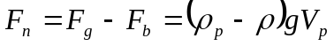
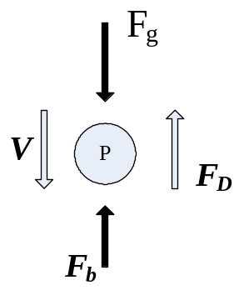
Drag force
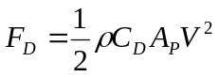

At ultimate settlings (at settling velocity, the impelling force = the drag force)
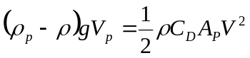
Solving for v:
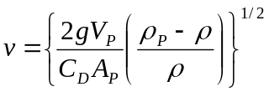3

For a spherical particle of a diameter d:
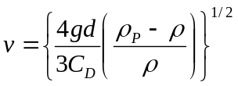

Where:
V_{p} = volume of particle; ρ = density of water
ρ_{p} = density of particle; F_{D} = drag force
C_{D} = drag coefficient; v = settling velocity
A_{p} = projected area of particles, cross-sectional area

To derive the formulas above we use the following properties:
Volume of a sphere = 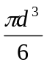
Area of a sphere = 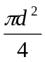

The drag coefficient (C_{D}) varies with Reynolds Number (Re) and the shape of the particle: (Most of time we are in the laminar range)

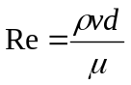
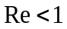: 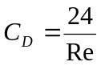 (Laminar range)
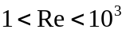: 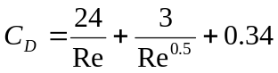 (Transition)

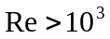: 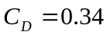to 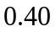 (Fully turbulent or Newton’s range)

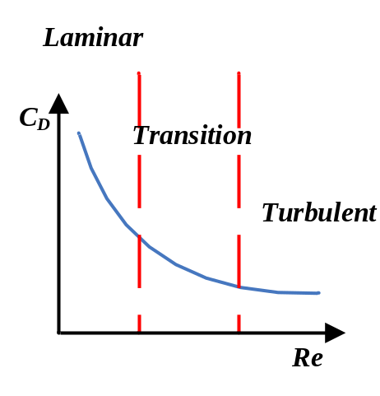
At discrete settling, the velocity is equal to:

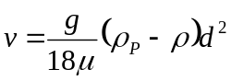 (Laminar or Stoke’s range)

The design of ideal settling basins takes into consideration the removal of all particles that have a settling velocity greater than a specified settling velocity.

In this case the design is based on discrete particle settling.

While designing a settling tank, we specify what our settling velocity is and we design the tank such that all particles with this velocity or greater will be removed; also some particles with smaller velocities will also be removed.

Ideal horizontal flow sedimentation basin

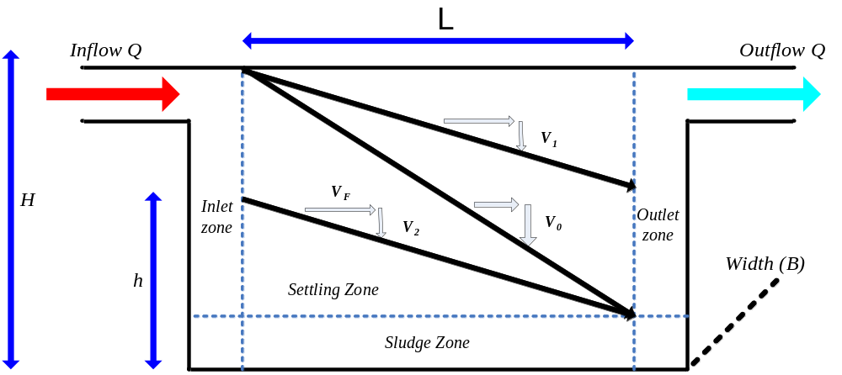

Where:
V₀ = is the design particle settling velocity
V₁ = V₂ = is the velocity of a particle with a smaller settling velocity than the design velocity.
t_{d} = is the detention period; the time it takes a particle to travel in and out of the tank.

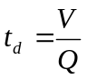; 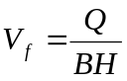
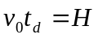; 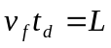
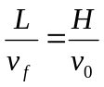 and 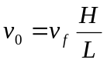
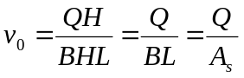 (A_{s} = is the surface area)
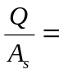 Surface overflow rate (SOR)
- Short circuiting: when water travels directly out… (Not our case)
- SOR = It is used as a design criteria for the design of settling tank. (although SOR = V₀ , we usually talk in terms of SOR in design not velocity)
- To improve the settling tank WITHOUT changing its dimension we can try to add horizontal trays (flat sheets), or inclined trays (Which is better)…

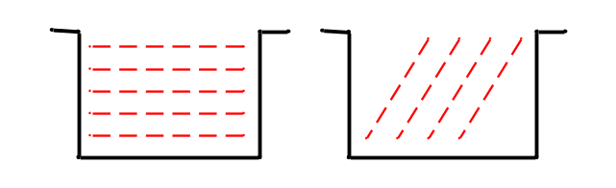

Particle removal in settling tanks

All particles with a settling velocity equal to v₀ or more will be removed to the settling tank while particles with settling velocities less than v₀ will be partially removed depending on their level of entry to the settling tank.

Assuming that a particle with settling velocity v, which is less than v₀, will travel a vertical distance, h, in the time t_{d}; then h = vt_{d}

All particles with settling velocity v that enter at a depth h or lower will be removed.

The criterion for removal of particles with this settling velocity is:
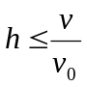

The fractional removal of particles with this settling velocity is:
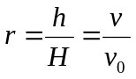

To determine the efficiency of a settling tank, i.e. the percent removal of suspended solids for discrete and flocculent settling, two methods are normally adopted. The first is the Particle Size Distribution method and the second is the Settling Column Analysis method.
The first is performed by establishing a settling velocity cumulative frequency curve. This is performed by classifying the percent weight fraction greater than the stated size for particles of different sizes, then determining the settling velocities and Re of each weight fraction. The curve is then drawn using the generated data, fraction with settling velocity less than stated v/s terminal settling velocity.

Efficiency of treatment = 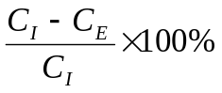 (Particle size Method)
C_{I} = Concentration Influent
C_{E} = Concentration Effluent
The previous method can only be used if all particles have the same density; this is why we can not apply this method to flocculent particles. More will be discussed later.

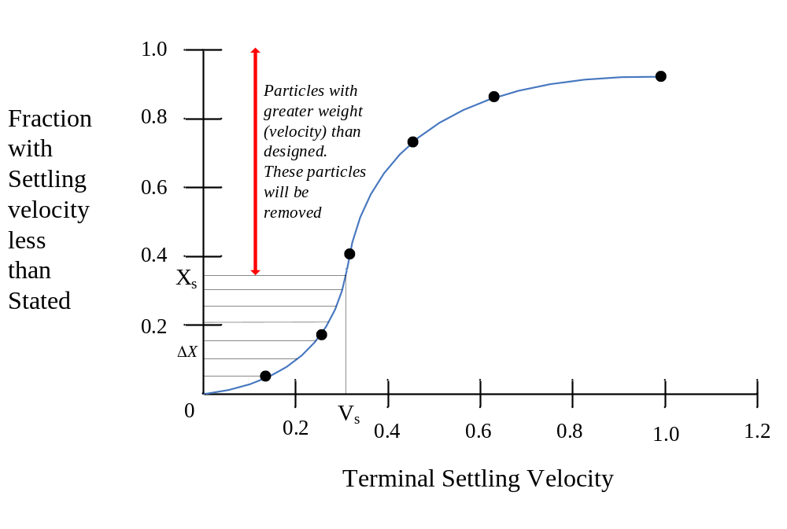
The overall removal may thus be calculated using the following formula:

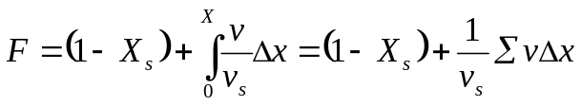 (v_{s} is the settling velocity, &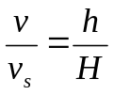)

The Settling Column Analysis is conducted by performing a settling test using a column from which samples are withdrawn at regular time intervals from multiple ports along the column and analyzed to determine the reduction is suspended solids.

Note: In the above formula take v_{s} as the average between two velocities… This method will not work with flocculent particles, since flocculent particles change their densities and velocities as they move downward (settle). So for flocculent particles we use the settling column analysis (take a sample and follow up, as shown below)…

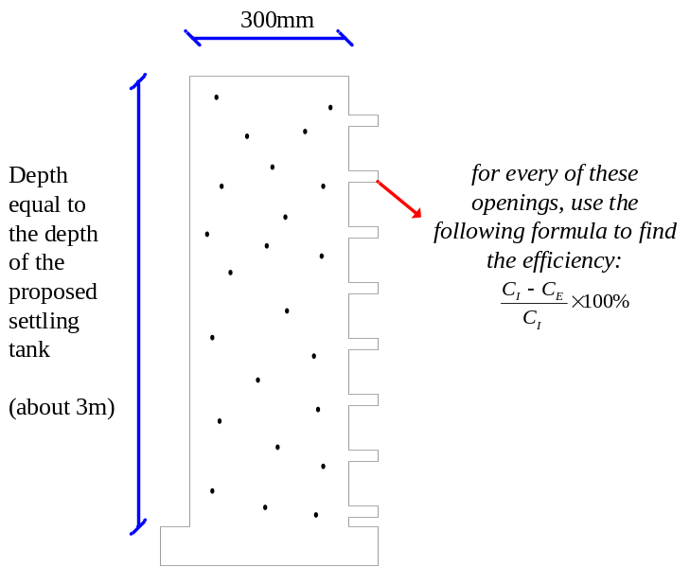

- Mix water to get even distribution of particles.
- At t = 0, take a sample and measure the turbidity and record
- At t = t₁, take samples from each opening; measure the turbidity and record…
- The samples taken up will have less particles than down…
- Then repeat the work in the 10-20 minutes for about 2 hours.
- You can change (increase) intervals of time, because settling will slow with time.
- After measuring the percent removal (efficiency) at different depth we plot a graph and get the following:

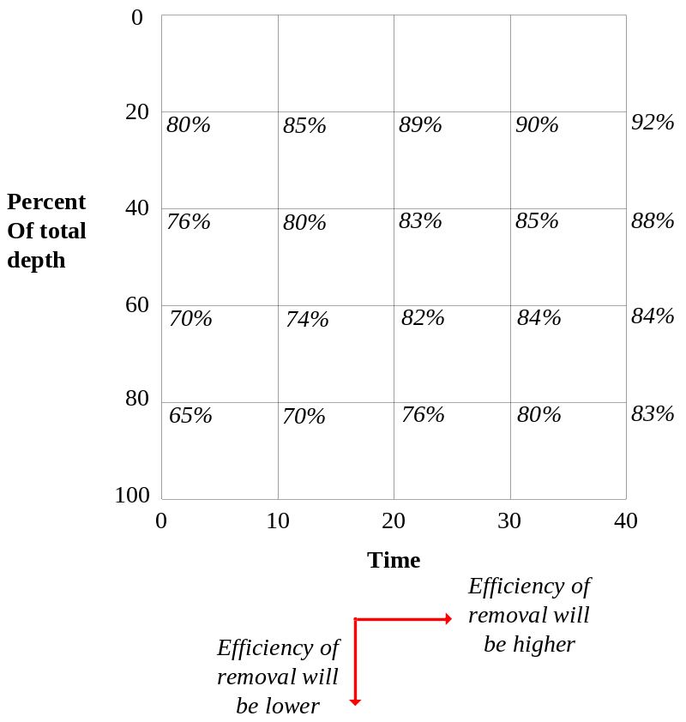
Percent removals are then plotted as numerical values versus depth and time as shown in figure. (as shown below, we join points having equal efficiencies)

From this plot the removal obtained at various times may be predicted and a theoretical SOR can be established.

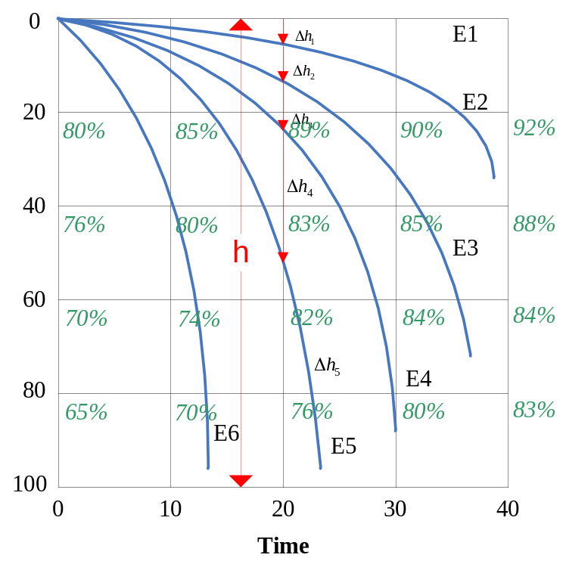

The efficiency may be calculated using the following relationship:
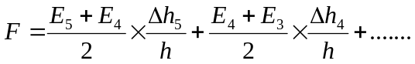
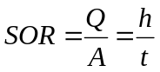
For example to find the efficiency at 20 minutes we draw a vertical line at t = 20 minutes and we use the above formula… so we’ll get:
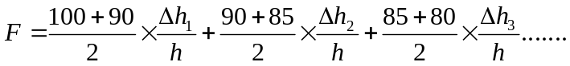
After we find the percent efficiency of removal for a certain time, we multiply this time by a factor of safety of 1.5. So for example if we get 70% removal for a time of 40 minutes, then we use (practically) a time of 1.5 40 = 60 minutes…
We use the above method for flocculent particles since velocity & density of particles change while particles are settling, since these particles get heavier & heavier and thus gaining speed as they move down…

Hindered Settling

The governing principle for design of settling tanks is v_{s} < Q/A_{s} and the limiting settling velocity of the suspension will be the design settling velocity v_{s}.

The rate of settling in the hindered settling region is a function of the concentration of solids and their characteristics.

Settling tests are usually required to determine the settling characteristics of suspension where hindered and compression settling are important consideration. The settling column analysis is normally used to obtain the needed data.

Special tanks are used as secondary tanks to make water thicker and these are called thickening tanks. In these tanks hindered settling occurs at the beginning of the tank since we’ll have a lot of particles after the Coagulation/flocculation process and particles will thus affect each other, causing hindered settling…

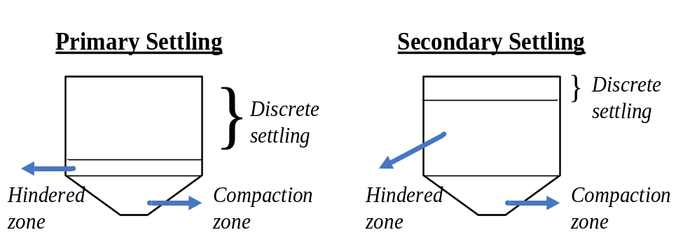

Interface: Is the line between the liquid and solid phase (considering that all particles move at the same time)

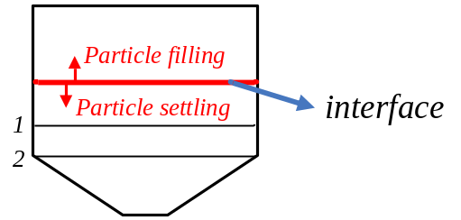

The line (or interface) is receiving particles from up, therefore it is increasing in size. However at the same time it is compacting. So the net movement (up/down) of this line is the difference between the filling and compaction (or settling) at the interface. Assuming that these two are equal, we can say that the movement of the interface line in the zone above 1 (hindered zone) is faster than it is between 1 & 2 (transition zone) and faster than below 2 (compaction zone). In other words we can say that as the interface line moves downward it somehow decelerates… more concerning this is illustrated in the graph next page.

The area requirement for thickening is determined by measuring the rate of subsidence of the interface in the settling column test and drawing a graph. The final overflow rate selected should be based on a consideration of the following factors:
- The area needed for clarification (Discrete settling)
- The area needed for thickening (Hindered settling)
- The rate of sludge withdrawal (Consider in practical approach)
Because the area required for thickening is usually greater than the area required for settling, the rate of free settling rarely is the controlling factor.

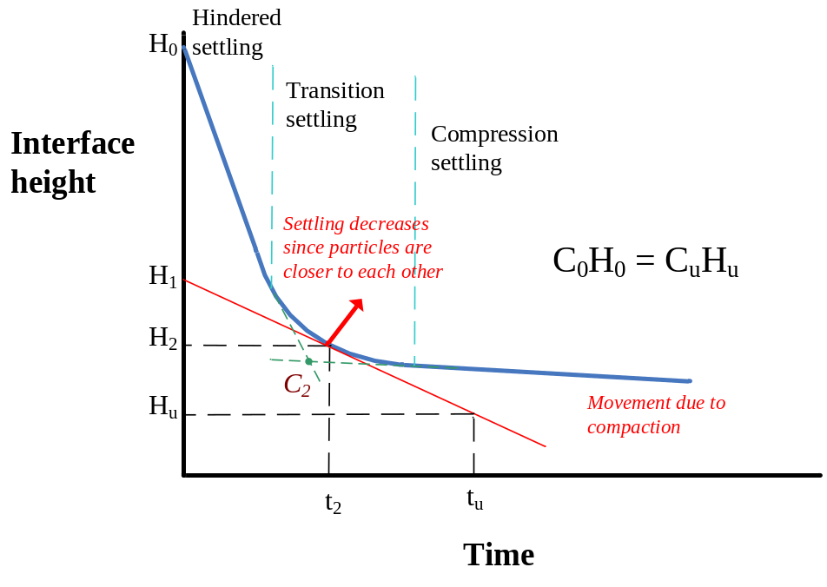

As I explained before the rate of movement of the interface in the hindered zone (steep slope) is faster than it is in the transition (curve) & compression zone (mild slope)…
We design the tank for either hindered or compacting settling. If we are interested in designing for hindered settling, we can take the slope of the hindered phase as the rate of settling to determine a detention period for a certain concentration. If we’re interested in the compaction settling we use the slope of the compression settling phase…
To determine a good estimate of the detention period we proceed as follows:
- Extent the hindered and compression curves till they meet.
- Find these two lines’ bisector and extend it to the curve.
- Draw the tangent of this curve at the point of intersection
- Knowing C₀, H₀, and C_{u} find H_{u} such that C₀H₀ = C_{u}H_{u}.
- Using the tangent (which we drew) and knowing the value of H_{u}, get t_{u}.

After we get t_{u}, the underflow detention time we can now get the surface area…

The rate at which the interface subsides is equal to the slope of the curve at that point in time.
The area required for thickening is given by the following equation:
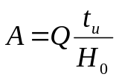
The critical concentration controlling solids handling capability of the tank occurs at height H₂ where the concentration is C₂.

Scour

The horizontal velocity in a settling tank should not exceed the scour velocity or else the settled particles will be re-suspended.
The scour velocity is given by:

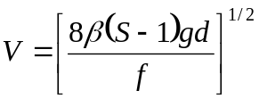

Where: v = horizontal velocity of flow
S = Specific gravity of the particle
d = diameter of particle
β = a dimensionless constant ranging from 0.04 to 0.06
f = dimensionless Darcy-Weisback friction factor usually 0.02 to 0.03

In determining the size of a settling tank, three design criteria have to be satisfied, namely, surface overflow rate (SOR), detention period, weir overflow rate (WOR). Based on the type of settling tank being designed, a specific SOR range, a detention period range and an WOR range are specified. Based on these values the size and dimensions of the tank are determined using the following steps.

- Determine the volume of the tank
V = Qt, where V is the volume, Q is the flow, and t is the detention period.

- Knowing the volume and the SOR, the surface area of the tank may be determined from the following:
SOR = Q/A

- Having the volume and the area, the depth of the tank is determined;
d = V/A; d normally ranges between 3 and a maximum of 6 m.

In designing a settling tank we consider three criteria (as stated above) which are:
- SOR
- WOR
- Theoretical detention period
- The theoretical detention period is different from the actual detention period because of some environmental factors. These include wind that can impact the movement of the water horizontally, or water having different density/temperature which will results in currents that will cause the water to stay for less time…This is why design criteria of a tank is based on experience.
- The water overflow rate (WOR) is rate at which water goes over the weir. If WOR is too high will result in turbulence in the tank which can pick up particles… So we should control the flow over the weir such that to have no turbulence…
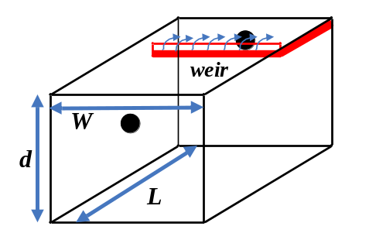

Units: WOR is expressed in m³/m/ unit time or m²/s, while the SOR is expressed in m³/m²/ unit time or in m/s. The detention period t is expressed in hours and the flow Q in m³/day (We have to convert the units when we use the formulas).
Dimensions: Usually we prefer to have a depth between 2 – 3.5 meters. Also the average optimal ratio of the width to the length of the tank is 1:3 to 1:5 (the width should not be bigger than the length).
Formulas:
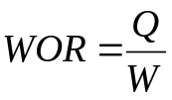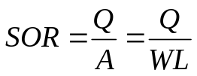
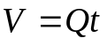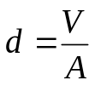
If the WOR is larger than the specified range and we don’t want to change the dimensions of our tank then we can do the following:

- Increase the length of the weir by zigzagging the weir
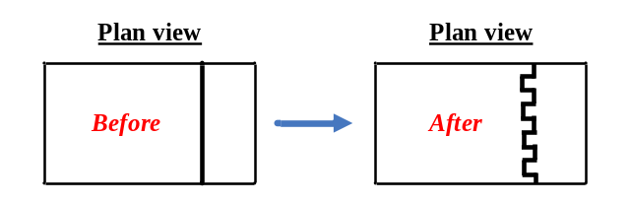
- Add another trough (double weir system)
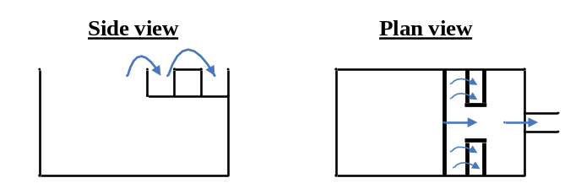
Types of settling tanks

Settling tanks could be either rectangular, circular, square, tube settlers. The most commonly used are the rectangular and circular tanks.
We have two types of tanks
- Rectangular (usually used for water treatment; more efficient for small areas)
- Circular (usually used for wastewater treatment; gives a better distribution of water in the tank)

Rectangular tank

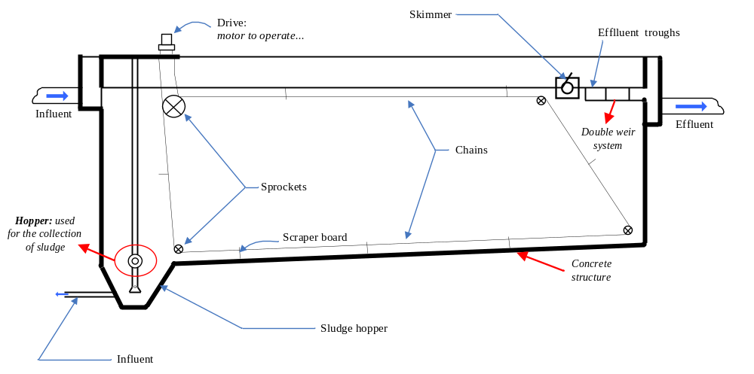

- The inlet structure should be designed to distribute the water as much as possible in the tank (we have to get a good distribution).
- In this settling tank we have two types of wastes which are scum and sludge. Scum will float and sludge will go down (settle) because the density of scum is less than that of water, while sludge has a density greater than water so it’ll go down.
- Scraper board: made of plastic or wood (rose wood) they are connected to two chains that enable they’re movement; as it turns it scrapes the sludge down towards the direction of the hopper.
- Skimmer: it is a truncated pipe that collects scum coming from the scraper board. (this is how we get rid of scum).
- Hopper & sludge removal: sludge can be removed by 2 methods, 1 is to insert air through another pipe which will result in lighter air that will push the sludge upward… and the other is due in pressure the pipe that will allow the sludge to go out (I am not sure about 😐 this one).

Circular tank (side view)

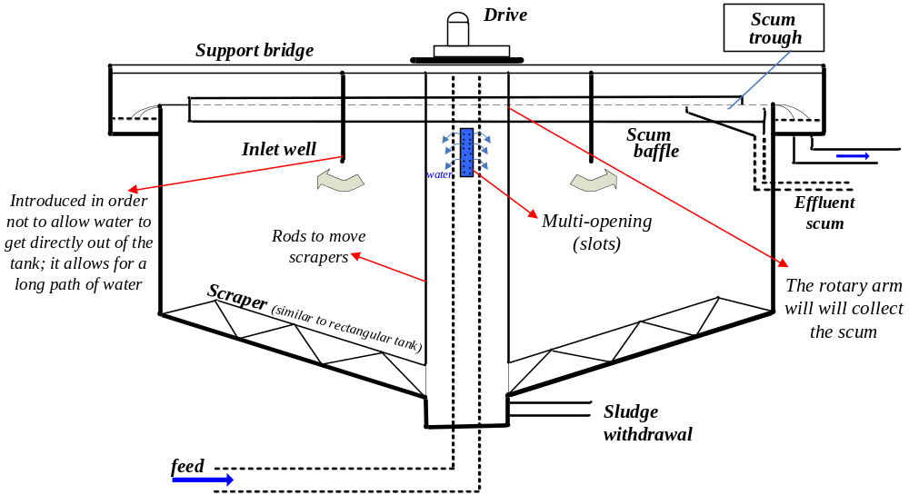

(Top view)
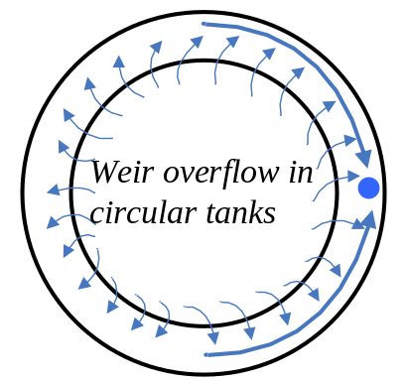

During the settling process we usually use a system consisting of more than one settling tank in case something goes wrong. For example if we consider the case where we have two tanks then if one of these is stopped the flow of water will all be transferred to the other tank, this will reduce the detention time which will result in less settling (less efficiency of removal)… Moreover the increase in the flow of water will cause the tank to overflow…

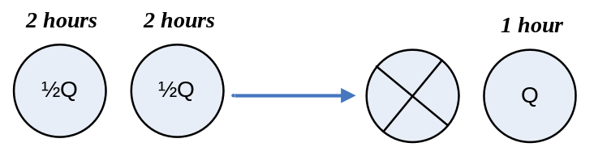
The main problem that will occur due to this is not really related to efficiency, since most of the particles will be removed at the beginning of the settling process (as shown in the graph). The main problem that will occur is the overflow of the tank because of the excess flow (the tank received an additional ½Q; the flow doubled).

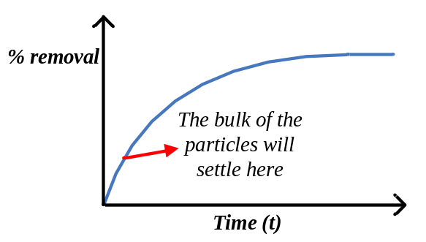

Now if we increase the number of tanks in our system we will avoid any overflow problem. If we consider that we have a system of four settling tanks, then in case one is stopped the other 3 will receive an additional flow of 1/12 Q which will not cause an overflow.

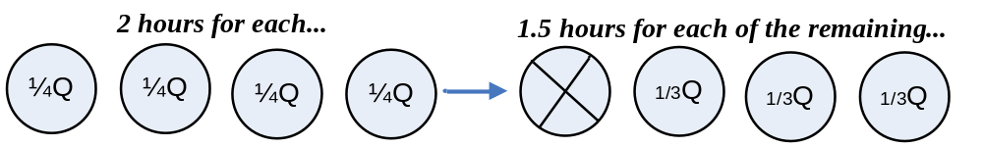

Design of Trough (or a launder)

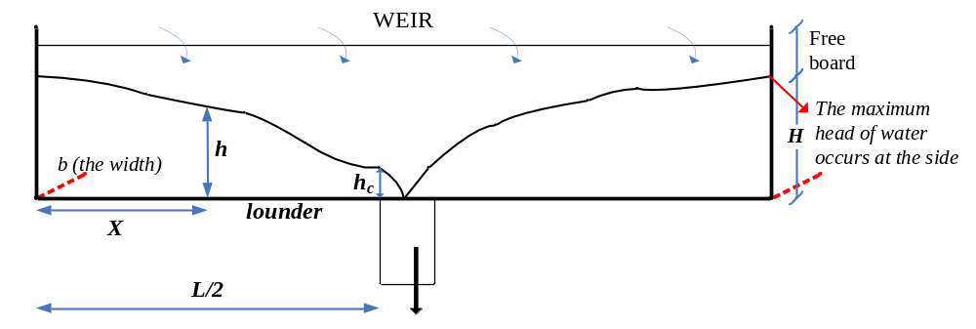
Free board = we allow for an extra 4 – 5 cm of height in the case water overflows…
In the formulas next page the following terms are defined as:
- h_{C} is the critical depth
- q is the overflow per unit length
- A (the surface area) varies with the section of flow, so take the areas of different sections and take their average…

Maximum depth, 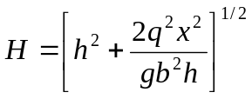
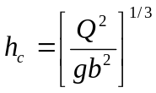
Substitute in equation for H,
then 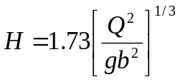
where b = width of the trough

Total depth of trough below weir;

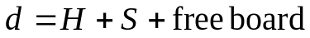

Where s is head loss per unit length;
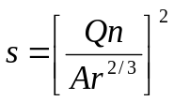
Free board = 5 cm

Design criteria are given as a function of the type of settling tank:

 | min | average | max
Detention time (t) | 0.2 h | 2-4 | 8
SOR m/d | 20 | 30-50 | 100
WOR m²/d | 175 | 250 | 350

Coagulation/Flocculation

Coagulation/flocculation is a treatment process that is used to remove non-settlable and colloidal particles from water and wastewater.

Coagulation involves the addition and rapid mixing of a part of coagulant resulting in destabilization of the colloidal and fine suspended solids and the initial aggregation of the destabilized particles.

Flocculation is a process where slow stirring or gentle agitation is effected resulting in further aggregation of the destabilized particles and form a rapid settling flock.

The non-settlable particles in water normally have sizes that range from 0.1 micron to 100 microns the bulk of which are colloidal particles. The movement of these particles in water is very much affected by electrokinetic forces which are a function of the concentration of surface charges.
The surface charge on colloidal particles is the major contributor to their long term stability. When a solid colloid stays in suspension and does not settle, the system is in a stable condition.

Particle charge results from preferential adsorption or from ionization of chemical on the particle surface.

In the previous process we removed settlable particles, and now we are left with nonsettlable & colloidal particles. In order to remove these particles we have to help them settle down; they are too small to settle and their movement is controlled by their surface charge, and since they’re mostly –vely charged they repel each other and remain stable. So we have to destabilize them to allow them to settle… this is why we introduce certain chemicals to facilitate the process (undertake coagulation/flocculation)…
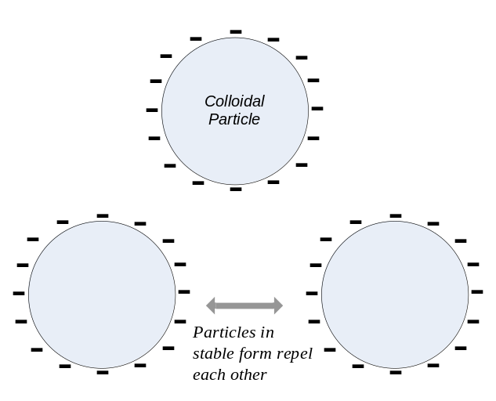

Destabilization: once we neutralize the charge of the particles, then we destabilize that particle, so they start moving and once they do they become able to aggregate…
Preferential adsorption: the affinity to attract other particles (it’s a source of charged particles along with ionization)

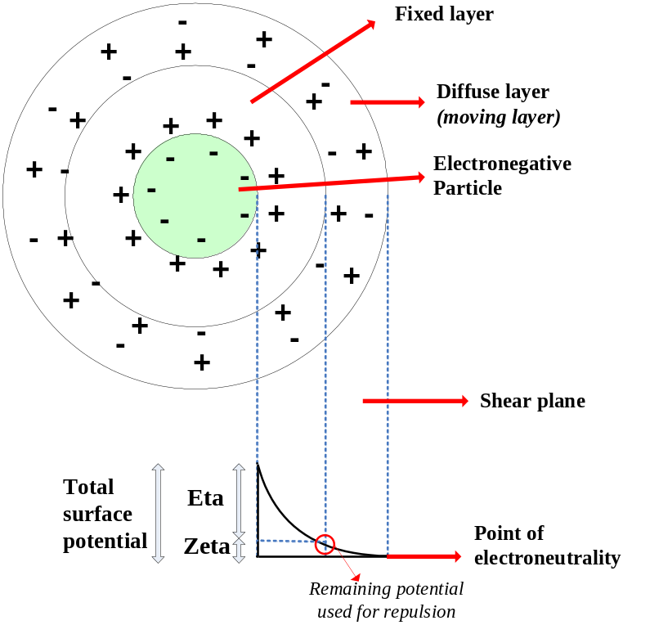
- A particle (which is –vely charged) is surrounded by two layer of waters, one fixed and the other moving. The electro-kinetic force of a particle has a certain distance where it is effective; this force is function of the –ve charges. In the coagulation/flocculation we aim to destabilize the particle for it to settle…
- The fixed layer is positively charged and will neutralize part of the –ve charges of the particle (Eta potential), this layer can rarely result alone in the destabilization of the particle. The thickness of fixed layer is a function of the concentration of +ve charges; the thinner the layer the less charges it has…
- The diffuse layer (or moving layer), has +ve and –ve charges and results in the neutralization of the remaining zeta potential. The zeta potential is what we aim to neutralize when we add extra +ve charges…
- Beyond the point of electro-neutrality the electro-kinetic force of the particle has no effect on other particles.
- When we add coagulants to neutralize the particles in water we should not add too much, because it will result in more +ve charges that won’t allow settling (repulsion will occur because the of +ve particles this time, so the best thing to do is to try to have it neutral). In order to know how much coagulants (or +ve charges) to add we can perform 2 tests, the first is to measure the potential of water using a special kind of voltmeter, and the second (more common) is to perform the jar test.
- The Jar test is performed to make sure that we add an optimal amount of coagulants to the water. It goes as follows:
  - Take samples from the water we are aiming to clean, place them in 6 jars.
  - Add to each jar different concentration of coagulants and mix.
  - You’ll then get in the different jars, flocks of different sizes and of different settling rates; these results will help us choose the optimal concentration of coagulant to use (a healthy flock will give an optimal speed of settling).
Coagulation involves the addition of chemicals – either hydrolyzing chemical or polymers.
Upon addition of coagulants to water, three reactions could occur:

- Dissolution of the salt (reduces zeta potential by altering the ionic concentration in the bound layer) (breaking up into ions)
Al₂(SO₄)₃ 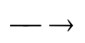 2Al(H₂O)₆⁺³ + 3SO₄⁻²

- Hydrolysis (This where the flocks form; as soon as the ion takes a hydroxide)
Al(H₂O)₆⁺³ + H₂O Al(H₂O)₅(OH)⁺² + H⁺
Al(H₂O)₅(OH)⁺² + H₂O Al(H₂O)₄⁵(OH)₂⁺¹ + H⁺

- Polymerization (Complex molecular structures, products of hydrolysis combine to form polymers)
Al₆(H₂O)₁₅⁺³
Al₇(H₂O)₁₇⁺⁴

Dissolution of salt (ionization): breaking up into ions; ions which are +vely charge attract –vely charged particles…
Hydrolysis: Flocks are formed as soon as ions take a hydroxide…
Polymerization; after hydrolysis we keep the flocks in water… and the more we leave them there the larger they become… we get polymers which have more complex molecules of hydroxide and which have a higher valence; the higher the valence the more particles it will attract and the better the coagulant… So polymers are very strong coagulants. Also you can have many types of these polymers, some organic and other inorganic but they are expensive.

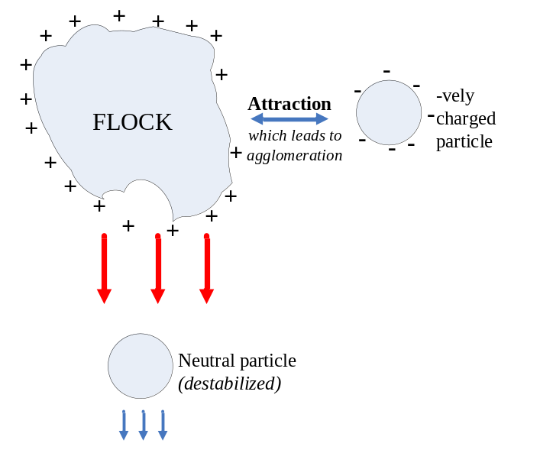
As the flocks move down they attract some –vely charged particles on their way, they also pick some other neutral particles (in their holes). This leads to agglomeration and to a heavier flock which will settle faster…

Net effect of the addition of coagulants is the formation of large, insoluble, positively charged particles and the production of free hydrogen ions from the water involved in the hydrolysis.

Types of coagulants:
- Aluminium Sulfate (Alum = market name)
- Ferrous Sulfate (Coppras)
- Ferric Chloride
- Ferric Sulfate

Each of these coagulants operates at an optimal pH.

- Alum and Ferrous Sulfate are mostly used.
- Each coagulant can work effectively in a specific PH, so we choose our coagulant according to the PH of our effluent … We can use the jar test to find the proper dose and coagulant to use…
- Sometimes the particles in water are not enough to create flocks that are heavy enough to settle/or they’ll settle down very slowly; in this case we add impurities to water (like clay) to increase the efficiency of removal… these additives are called coagulant aids… (more is discussed below)

Coagulant aids could include:
Oxidizing agents
Weighting agents
Activated silica (sodium silicate + alum).

Flocculation is carried out by slow mixing and the extent of mixing is measured by the mean velocity gradient.

The mean velocity gradient is related to the power input through the shear stress (γ) on an element of fluid.

- Oxidizing agents: If we have wastes of organic nature in water that’ll hinder the process of agglomeration, we remove them by adding some oxidizing agents; these may include ozone, chlorine, or other oxidizing agents that will neutralize these organic particles.
- Weighing agent; makes flock heavier (clay).
- Activated silica: It is a combination of a weighting and oxidizing agent; sodium silicate (sand) acts as a weighting agent and alum as an oxidizing agent.

  - In flocculation over mixing (fast) is bad (it breaks up the flocks); also slow mixing is bad (It doesn’t allow particles to get close to each other to agglomerate), this is why we should have optimum mixing conditions…

  - When water moves at a laminar range, we only get very slow mixing by diffusion; so we have to move to the turbulent range to get good mixing. Mixing occurs in the turbulent water because the layers of water are moving at different velocities (Velocity gradient)… So mixing occurs due to friction between the interfaces.

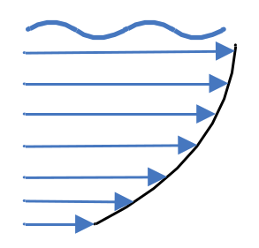

In the picture below we can see that the lower surface is moving at a lower velocity than the upper one, and this leads us to the following:

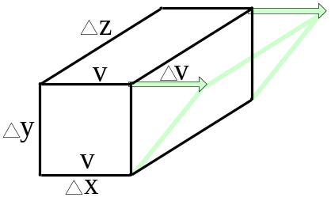
- 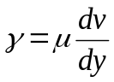
Where γ is the shear stress; μ is the dynamic viscosity; V is the fluid velocity; and dv/dy is the mean velocity gradient (or the rate of change of velocity).

- The power input is determined from:
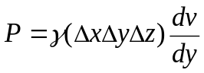
- The power input per unit volume is equal to:
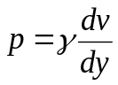
- Then 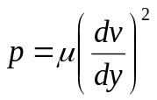
- dv/dy is expressed as G
- 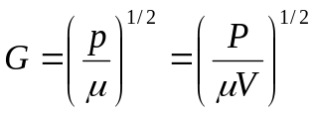

Dissipation of energy in a fluid is accomplished mechanically using paddles or turbine mixers, hydraulically in baffled channels (energy to head losses), and air by injection of air. (Agitation of air results in mixing)
…when we want to mix we need to determine the optimum power for mixing; then if we know G we can know the power…
Baffled Channel
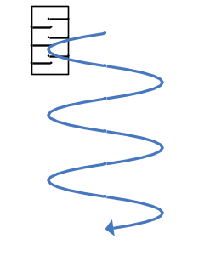

In baffled chambers the power dissipated is calculated using the following relationship:

- 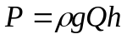 and the corresponding value of G is equal to:
- 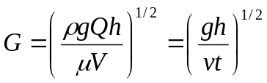
Where V is the kinematic viscosity and t is the hydraulic detention period.

Values for t are 20 to 30 minutes and for G are 25 to 65 s⁻¹.

Recommended Gt values are between 30,000 and 60,000.
Note: It is no use of having a good value of G or t if we obtain a value of Gt not in the range shown above.
Filtration

Filtration is a process in which water or wastewater is passed through a filter medium (Microscreen, membranes, granular) where the particulate materials are trapped through the effect of different mechanism (physical, mechanical, electro-mechanical) resulting in a highly clarified effluent.
Filtration is the process in which we remove the remaining small particles in suspension that did not settle out, or did not build enough weight. Water that is passes through a filter should have a relatively low turbidity (10 – 50mg/L), and after filtration water will be ready for supply (turbidity will be less 1mg/L). If you pass water with high turbidity in the filter it will cause clogging in a short time, and we will then need more water to backwash the filter than the water we have filtered…

Introduction:

Filters are capable of removing a wide range of particulate material of both natural and human origin.

Granular filters are classified according to:

- Type of medium
Sand, anthracite, etc (glass or any medium that can hold particles going down)

- Rate of flow
Slow, rapid, high rate
- Direction of flow
Down – flow, up – flow (or bi-flow), fine to coarse, coarse to fine
- Pressure of flow
Gravity flow
Pressure flow
The most commonly used filter types are the slow and rapid filter that use sand or a combination of sand and anthracite filter media.

- Fine to coarse filters (meaning that fine particles are above coarse particles considering that water is coming from up…) Normally filters are from fine to coarse because fine particles go up… But in filtration it is better to have coarse to fine filters because you’ll be able to use a better depth; coarse to fine particles will prevent fast clogging since large particles are trapped up (in the coarse particles) while smaller particles are trapped downward.

Slow sand filters:

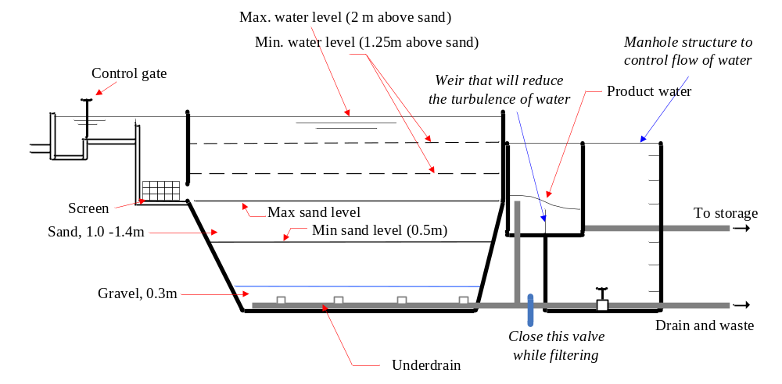
Slow sand filters:
- Water coming in the filter passes first through a screen and then goes over the sand layers. Water builds up over the sand layers which forms a head that allows to overcome friction and to pass through the sand …
- When clogging occurs in this filter we remove the upper layer of sand that is clogged (2-5 cm). We keep on doing this when the filter is clogged until we reach the minimum level of sand, where we remove everything and start over…
- The gravel in this filter doesn’t do any filtration; it acts as a supporting medium.
- When we remove sand from the filter (using a shovel, etc..) the efficiency of the filter decreases a bit, but this is not a problem… this is why we have a minimum sand level…(
- Slow sand filters are used for small communities (villages), and they need large areas to operate. Rapid sand filters are smaller in size and are used in cities…

The slow sand filters are characterized by:
- Low filtration rates which vary between less than 0.4 m/h (0.4 m³/m²/h) to up to 1.5m/h (1.5 m³/m²/h)
- Require the development of a gelatinous surface coat of biological growth (schmutzdecke) for proper operation on the filter. The growth of this coat extends between 6h and 30d.
- Raw water with turbidities of up to 100 mg/L may be applied to slow sand filters.
- The medium used is mostly sand with an effective size of 0.1 to 0.3 mm and a uniformity coefficient of 2 to 3.
- Duration of filter run could vary between 1 week to 6 months depending on the turbidity of the applied flow. Typical duration is 40 to 60 days.
- Cleaning of the bed is performed by scraping the top 12 to 50 mm of sand. The removed sand is cleaned stored and returned back to filter at a latter stage.
- Standard units of up to 6000m² may be used. The size of the individual units is governed by the need to provide the required flow while at least one is out of service.

Schmutzdecke: Is a gelatinous layer of bacteria that will assist in the filtration process in slow sand filters. This layer of bacteria will work as a filter membrane with very small openings that will filter on the level of molecules. As mentioned above it needs 6 hours to 30 days to grow (it grows on its own), and once it does it will result in optimum filtration. (We will still get good filtration if its not present… but we’ll get better filtration if its present)

The effective size: The sieve size that will allow 10% by weight to pass through the sieve. (D₁₀)
The uniformity coefficient = 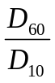
Note: As in previous process, use more than one unit to maintain a good quality of water.

Rapid sand filter
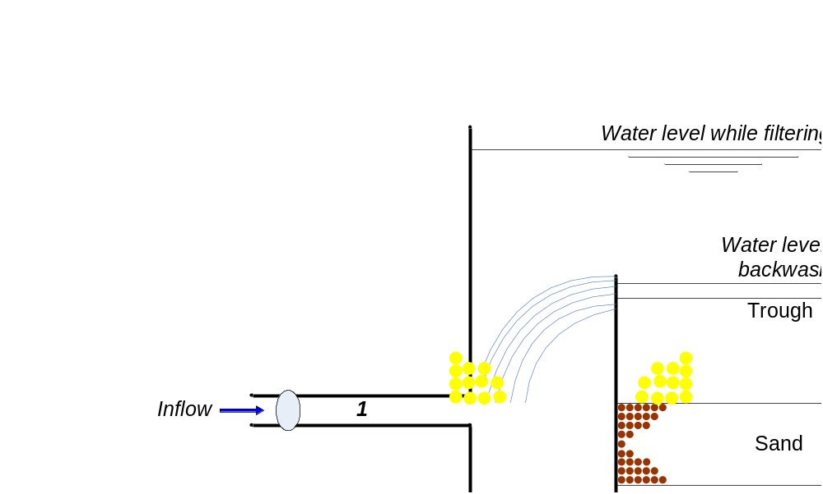
- For municipal water, the most used type of filters are rapid sand filters that operate at high rates and need a small area to do the work.
- The above drawing represents 1 section of the filter unit. A filter system has in fact many units (it is composed of more than 1 rapid sand filter).
- The rapid sand filter has 3 steps (or phases): filtration, backwashing, and filter to waste.

  - Filtration: (Only the valves labelled 1 are opened during this process). Water comes in (from the inflow valve), goes toward the sand and gravel layer where it is cleaned, it then exits the filter.
  - Backwashing: (only the valves labelled 2 are open during this process). Backwashing is the process in which we clean the filter; this is why we allow water to go in reverse direction. Water comes from the storage, and then goes in the reverse direction of filtering. The process fluidizes the sand (sand particles will hit each other, and releasing impurities), the dirt or impurities will go through the trough (overflow) and then back out. (Note: when you fluidize the sand particles expand up to 40%). The process takes 10 - 20 minutes.
  - Filter to waste: (During this process the valve 3 is open + the inlet valve). After we washed the system, we need to use it as a filter again, but we can’t for now because the sand particles are not sitting in their original depth (The layer has expanded). So the water that passes at first is not so clean (not properly filtered). This is why we let water pass for 5 to 10 minutes to drain, after this process we can go to filtration again.
- The flow controller is used to control the flow of water out of the filter. We need it since after a certain time of filtration, the bed starts to clog, and the rate of flow decreases less and less, and water starts building up…
- The trough is not involved in the filtration phase; it is only used in the backwashing phase.
- If water has a high turbidity, you’ll have to backwash every ½ an hour, so then we have to carry out first primary settling, coagulation/flocculation and… (all the previous steps).
- Rapid sand filters are 10 times faster than slow sand filters.

Filter characteristics and design consideration
- Rapid sand filters operate at filtration rates ranging between 100 and 475 m/d. Normally 120 – 240 m/d.
- Depth of bed is 0.5 m - 0.75m.
- Size of sand: Effective size = 0.45 – 0.55 mm and higher uniformity coefficient = 1.2 – 1.7.
- Size of anthracite: effective size = 0.7 mm or more and a uniformity coefficient of less than 1.75.
- Garnet sand: Specific gravity = 4.2
- For equal settling velocities, the required particle sizes for media of different density are calculated by:

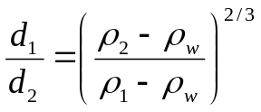

Anthracite + sand (Dual medium filter): anthracite is coal that has an effective size larger than that sand but which has a smaller specific gravity (lighter- specific gravity of anthracite is around 1.5 while sand is around 2.65). Since it anthracites are lighter than sand, then they’ll go up… so water will move from coarse (anthracite up) to fine (sand down).
Garnet sand has a size of 1 – 2 mm; it is used as a medium between the gravel and sand to prevent sand from passing through. We usually don’t fluidize it (it needs a high velocity to fluidize because it’s heavy).

To choose the sizes of sand and anthracite use the above formula as follows:
d₁ = the diameter of the anthracite particle; d₂ = the diameter of the sand particle
ρ₁ = the density of the anthracite; ρ₂ = the density of the sand
d₁ is the size of anthracite that will give you the same weight as the sand of size d₂, but we want anthracite to be lighter so we reduce d₁ by a certain fraction maintaining d₁ > d₂. So finally we’ll get a larger anthracite particle but having a smaller weight…

- Length of run is 12 to 24 to 72 hours. (Never go beyond 72 hours)
- Penetration of suspended matter is deep.
- Preparatory treatment of water before filtration:
Flocculation/Sedimentation
- Method of cleaning is by backwashing; scour by upward backwash flow using filtered water.

Filters are designed to handle the flow as a battery of filters. The battery in turn is composed of at least two units. Each unit operates independently. Unit sizes are usually standardized based on the flow capacity.
To design a filter, a flow rate is established in terms of m³/m²/d. knowing the total flow to be treated per day (m³/d), the area of the battery is determined by

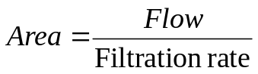

Choosing a standard unit filter size, the number of units is determined.
The net water produced per day will be equal to the total water filtered by the battery, based on operating time, minus the water used for backwashing.

- The efficiency of treatment increases when we increase the number of filters in a battery.
- To design a battery (determine the area) of filters we divide the quantity of water (the flow) we have by the filtration rate to determine the area. For example if we have to treat 10000m3/day, and we pick a unit that will filter 1000m/day then we’ll need 10 units. Knowing the total area needed, we divide it by 10 and we get the area of each unit.
- The optimal dimensions of a filter are L = 1.25 – 1.5 W
- The time and quantity of water used for backwashing should be accounted in our design. (Deducted from the total operational time and total quantity of water).

MECHANSISMS OF REMOVAL

Particulate materials are removed in a filter through various mechanisms including:

Straining
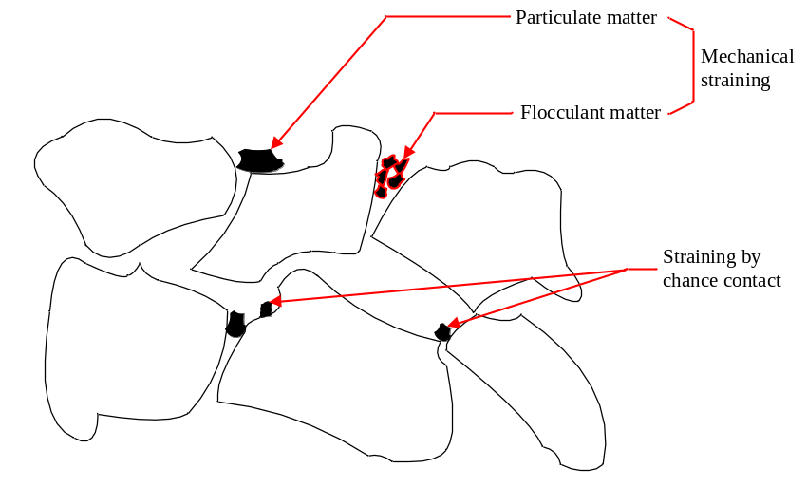

Straining occurs when a particle can not pass through the particles of sand and gets stuck. We have 2 forms of straining, mechanical or by chance straining. By chance straining occurs when a particle of a small size is stuck while it may have passed if it had passed through another route.

Sedimentation/Inertial Impaction

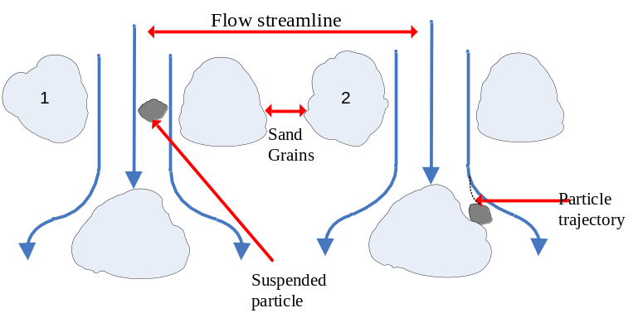

Sedimentation occurs when the space between sand particles acts as a settling tank, particles travel through a streamline, when the stream line turns around a corner, the velocity is reduced and the particle falls out of the stream line (because of its weight) and settles on the sand grain.

Interception
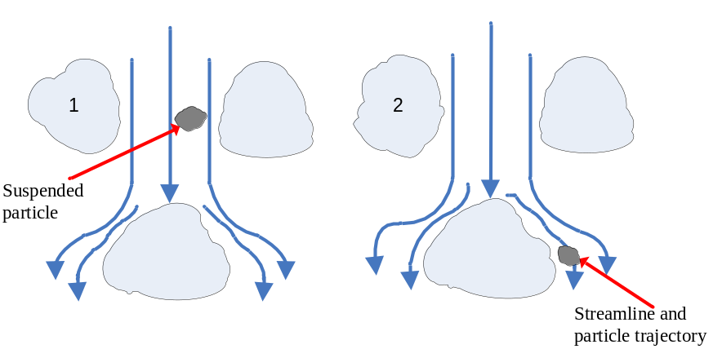

Interception occurs when the stream line is very close to the surface of the sand particle; it hits the surface and sticks on it by an electro chemical force or by adhesion. For interception to occur the distance between the particle and the sand particle should be less than ½ the diameter of the particle.

Adhesion

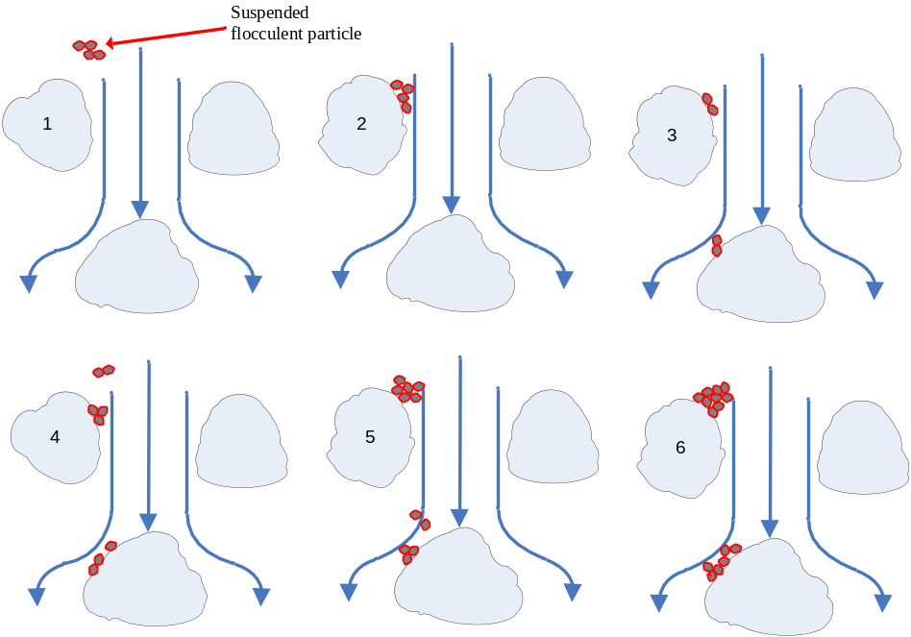

Adhesion occurs when flocculent particles (which are not well stuck together) come in contact with the sand particle and stick (adheres or clings) to it. Some will shear of because of the flow and will stick on other sand particles… Flocks are like a piece of cotton and can easily adhere to surfaces, they start building up…

Flocculation
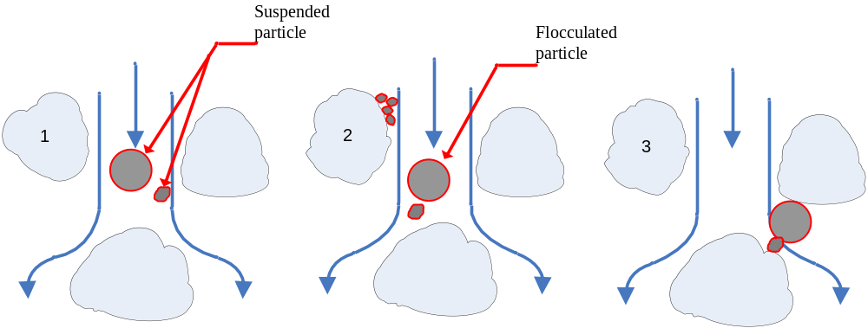

Flocculation in this case occurs due to velocity gradients (because we are moving from an open area to a restricted area or vice versa) that will create some kind of mixing (Coagulation/Flocculation). The volume of particles will increase and this will lead to straining.

To determine the quantity backwash water requires the determination of the backwash rate. This is based on the backwash rate of flow (velocity, V_{b}) that will fluidize the medium and will generate maximum abrasion. However another important velocity that needs to be determined is the terminal velocity (V_{t}), which represents that velocity at which the medium particles will overflow from the filter.

The terminal velocity, V_{t}, is determined from;
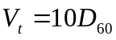 for sand and 4.7D₆₀ for anthracite.
The velocity needed to fluidize the bed is calculated from:
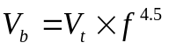
Where f is porosity of medium

Backwash: Water in the backwashing process should be enough (quantity) and have a certain velocity to fluidize the sand bed. Sand is normally compacted in its resting position so we need a certain velocity (V_{b1}) to push it to a position where it is starts moving and another velocity (V_{b}) to keep it in suspension. While doing this we should make sure that V_{b} < V_{b1} < V_{t} (terminal velocity) so that the sand doesn’t overflow. So we begin by using V_{b1} for a short time to fluidize the bed, then we use a velocity V_{b} (maximum abrasion velocity) for 99% of the backwashing time to keep the particles in suspension where they start hitting each other to release impurities.

The maximum abrasion velocity (V_{b}) at 20°C was empirically determined to be equal to 0.1V_{t} i.e. D₆₀ for sand and 0.47D₆₀ for anthracite.
It is important to note that temperature has a major effect on velocity and variations could be determined by the formula:
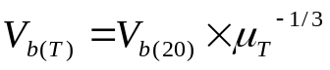
Where 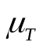 is the velocity in centipoise
Note:
- Temperature has an impact on velocity because viscosity varies with temperature. (as shown in the formula above)
- When you want to calculate the quantity of water need for backwashing, use the maximum abrasion velocity.
- If you are backwashing 1 unit, you should have enough water in the tank for at least another unit.
- Filter to waste process is not included in the backwashing process, so we have to count for the water and time used in this process

Another important criterion that has to be accounted for in the design of granular filters is to the head loss in the system. The head loss during backwash is the sum of the head lost in the expanded bed, the gravel, the underdrain and the piping system conveying the water to the filter. The head losses may be determined using the following formulae: (4 sources of head loss in general)
Head loss in expanded bed, 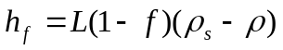 ( is the porosity)
(L is depth of the expanded bed)
Head loss in gravel, 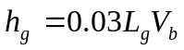 (L_{g} is the thickness of the gravel bed)
Head loss in underdrain (system that have nozzles), 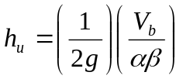
Where α is an orifice coefficient and β is the ratio of the orifice area to the filter bed area.
Head loss through the pipe can be calculated from the Darcey – Weisbach equation.
Minor losses through an elbow for example can be considered as 3 times the loss due to friction in the elbow.

Surface wash and air wash should be incorporated in all rapid filter designs to overcome a number of problems that might be associated with filter operation.

Surface wash could be performed by the use of fixed nozzle system or by rotating arm system.

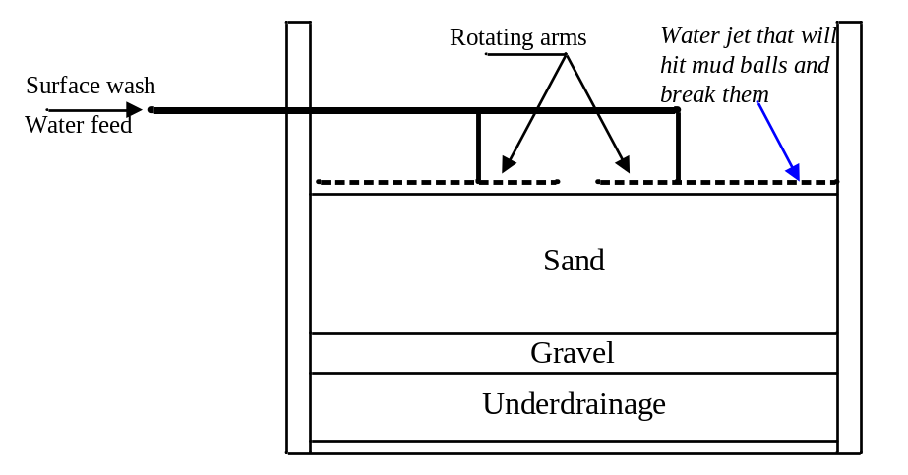
In certain systems air is incorporated in the backwashing process. (When air passes particles dislodge and water can pass)
Operating modes
Operation of filters could be performed either by the constant rate filtration or by the variable rate filtration.

Constant rate:
- Constant head loss – constant head; use control at outlet. Controller will open as head loss increases in filter bed.
- Constant head loss – variable head; use flow controller at inlet. Increases head over filter to control flow.

Variable rate:
Maintain a constant velocity of flow. Use a rate of flow controller to compensate for both the change in head loss in media and changes in surface water operation.
You will get different Q’s, their average will give us the Q we want.

Operating difficulties:

Air binding: occurs as a result of the negative pressure in the bed due to filter surface clogging. Controlled by backwashing at shorter intervals.
Mud balling: occurs as a result of the formation of a thick mud layer at the surface and the lateral pressure that is present in the bed and at backwashing which results in the formation of mud balls. Controlled by the use of surface wash.
Sand incrustation: occurs as a result of the settling of calcium carbonate on the particles of the filter medium especially where lime softening is used. This may be controlled by lowering of pH so as to prevent the carbonates from settling or to add polyphosphate to complex with calcium and keep it in solution.

- Air binding occurs when we don’t clean the filter for a long time, when complete clogging occurs. Sa the top surface clogs and the remaining water drains, a vacuum is created, so we get a negative pressure which pulls in air bubbles and they get lodged in between the sand particles. When we backwash, the air bubbles leave quickly and forms channels in which the water follows, so we get no proper distribution of backwashing. Also some bubbles will remain after backwash and the air will back water and will prevent it from going through.
- Sand incrustation occurs whenever the water is pretreated by lime to remove hardness. Calcium deposits on the medium particles and crusts form, so the size of particles increases and the effective size of sand particles are disturbed and voids between the particles increase, so larger particles pass through.

Pressure Filters
Pressure filters are used in water filtration for small communities and industrial complexes.

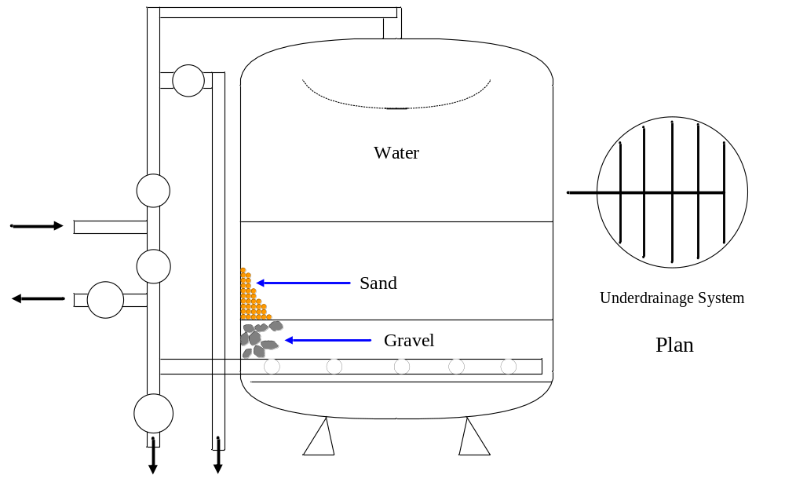

Filtration rates are very similar in the pressure filters and the rapid sand filters. Pressure filters could have higher rates at the expense of water quality.
Mostly used in industrial applications and swimming pools.

Miscellaneous Treatment Methods
Disinfection

Disinfection is practiced for destroying or inactivating disease producing (pathogenic) organisms.
Disinfection could be performed by one or more of the following methods:
- Physical treatment such storage or application of heat or other physical agents.
- Irradiation such as ultraviolet.
- Metallic ions such as copper and silver.
- Oxidants such as halogens, ozone, and other inorganic or organic materials.

  - The problem with UV radiation is that it doesn’t leave residuals, so during transportation to point of use the water gets polluted again. Because we have no residual therefore we can not kill the new bacteria.
  - Copper and silver effect both humans and bacteria but at different dosages. At low dosages the bacteria is killed but humans are not affected. But a mistake in dosage can kill people.
  - The most widely used halogen in disinfection is chlorine. Among these halogens we have iodine, bromine…
  - Ozone is stronger than chlorine but is more expensive.
  - Chlorine sometimes can form halogenated hydrocarbons which can cause cancer.

Each of these disinfectants has one or more limitations. The most widely used disinfectant is chlorine and some of its compounds.

When added to pure water, chlorine forms hypochlorous acid (HOCl) and hydrochloric acid (HCl). Very little chlorine will be found in its free form. Hypochlorous acid ionizes or dissociates practically instantly into hydrogen (H⁺) ions and hypochlorite (OCl⁻) ions to a degree depending on the pH and temperature.
Cl₂ + H₂O 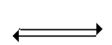 HOCl + HCl
HOCl OCl⁻ + H⁺
- Chlorine is the strongest disinfectant followed by hypochlorous acid, followed by hypochlorite ion in water. Chlorine can be found in water in the form of Cl₂ unless the pH is lower than 4, usually it is found as hypochlorous acid and/or hypochlorite ion.
- At a pH of 7 it is a combination of HOCl and ClO⁻. At a pH 10 or 11 we have 100% ClO⁻. At a ph of 5 or 6 we have a 100% HOCl.

Compounds of chlorine such as calcium hypochlorite [Ca(OCl)₂] or sodium hypochlorite (NaOCl) may also be used:
Ca(OCl)₂ Ca²⁺ + 2OCl⁻
H⁺ + OCl⁻ HOCl

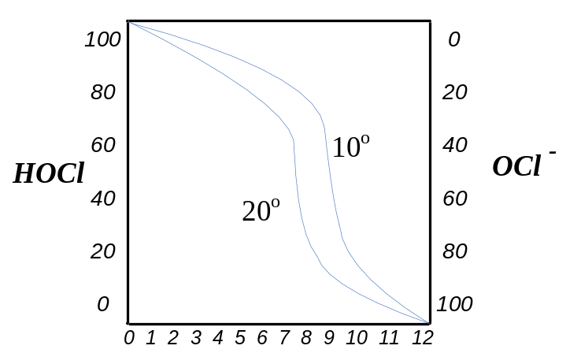
Ca(OCl)₂ is found in powder form. Cl₂ is found in gas form. At higher temperatures more HOCl is found while at lower temperatures more ClO⁻ is found.

In the presence of ammonia (NH₃), a reaction occurs and results in the formation of chloramines in different forms:
NH₃ + HOCl H₂O + NH₂Cl
Monochloramine occurs at pH > 7.5
NH₂Cl + HOCl H₂O + NHCl₂
Dichloramine occurs at pH 5 to 6.5
NHCl₂ + HOCl H₂O + NCl₃
Trichloramine occurs at pH < 4.4

The reaction is affected by pH, time, temperature, and initial Cl₂:NH₃ ratio usually 4:1
Chloramines are known to be more stable in water than chlorine.
The advantage of chloramines is that they are stable; they do not oxidize anything like chlorines. Chloramines remain longer in water, so we get residuals.

Terms used in the chlorination process:
- Free Residual Chlorine
- Combined Residual chlorine
- Available Chlorine
- Free Residual Chlorination
- Combined Residual Chlorination
- Chlorine Demand
- Plain chlorination
- Prechlorination
- Post Chlorination
- Rechlorination
- Dechlorination

Free Residual chlorine: Chlorine that remains in water after chlorination/ disinfection in its free form (ClO⁻ or HOCl).

Combined Residual chlorine: chlorine residual in the combined form such as chloramines (NH₃ + Cl₂).

Available chlorine: chlorine that is available to oxidize microorganisms in the water.

Free residual chlorination: carrying out chlorination with the intention of having a residual.

Combined residual chlorination: carrying out chlorination with the intention of having a combined residual.

Chlorine demand: chlorine amount needed to oxidize the utilizable material found in water. (Organic, inorganic, or bacterial)

Plain chlorination: The process when chlorination is the only method of treatment used.

Prechlorination: When we chlorinate before any other method of treatment. This will help in inhibiting any bacterial growth in the treatment plant, especially in filters.

Post chlorination: when chlorination is done after all other treatment processes.

Rechlorination: When chlorination is performed beyond the treatment plant (i.e. chlorination as water leaves a storage tank)

Dechlorination: When we want to remove excess residual chlorine (in the case of excess chlorination). When there is too much chlorine that the water smells or when the water has a bad effect on other treatment process.

Major considerations that affect the bacteriacidal efficiency of chlorine:
  - kind and concentration of disinfectant
  - Contact time provided
  - Chemical character and temperature of water
  - Kind and concentration of organisms to be destroyed.

To achieve complete disinfection, use breakpoint chlorination. This will determine the dose needed to oxidize all the oxidizable material and achieve a complete kill of all the bacteria and leave residual chlorine which could be needed at later stages of the distribution.

- Contact time to kill bacteria is about 15 – 30 minutes.
- Chemical character of water: Does the water have oxidizing material in it? If yes, it may take up some chlorine before it can attack the bacteria.
- As temperature increases more HOCl breaks up into ClO-, and ClO- is less effective in disinfection.
- Some organisms cannot be killed very quickly with chlorine then the higher the concentration of chlorine then the higher the probability that all the bacteria will be killed.
- Breakpoint chlorination test is performed to make sure that everything is oxidized and a residual is left.

Break point chlorination curve

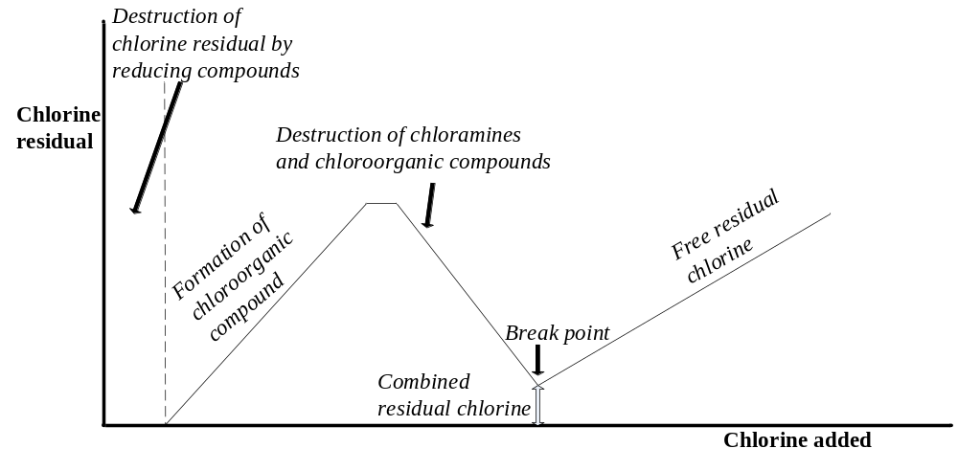
- Get a sample of water and add chlorine and measure the residual. The initial batch of chlorine will be taken up by oxidizable materials, then chlorine will combine with other compounds to form combined chlorine. Then there will be a point where the combined chlorine will react with bacteria and their will be a sharp drop in chlorine concentration up to a point where all the oxidizable materials have been oxidized (break point).
- After the break point if we add chlorine there will be a sharp rise in free chlorine residual. (There will also be some combined chlorine left over from before the break point)
- Free residual chlorine cannot occur before the breakpoint where there is 100% disinfection.

The amount of chlorine needed to accomplish disinfection will depend on:
- The chlorine demand
- The amount and kind of chlorine residual
- The time of contact of chlorine with water
- the volume of flow to be treated

The required chlorine feed rate is obtained as follows:
(Max. dosage, mg/L) (Max. flow, L/day) = (chlorine feed rate capacity, mg/d)
Quantity of chlorine to be stored should be equal to the quantity needed for two weeks operation.
Kind of residual: Combined or free chlorine residual
The less the time of contact, the higher the dose of chlorine.

Other methods of disinfection:
Ozonation:
Ozone is strongly oxidizing agent.
Production of ozone is performed by passing a high voltage electric charge into cool dry air where O₂ will be converted to O₃. The third atom is loosely bound and easily splits to unite with organic matter.

1% of atmospheric O₂ is converted to O₃ at 0.025 kwh/gr O₃.

Required dose ranges between 0.25 and 5mg/L with contact period of 30 seconds or less. Virus requires 0.25 – 1.5mg/L with contact 45 sec. to 2 minutes.

Some operational characteristics;
- There is no taste or odor to ozone in water
(Unless in very high concentrations, O₃ doesn’t have an odor).
- Ozone id not sensitive to pH (5 – 8)
- Ozone is affected by temperature (breakdown increases and solubility decreases with temperature).
- Because of its instability it lacks the residual and has to be generated on site.
- It cannot compete in cost with chlorine.

Ultraviolet rays:
These comprise the invisible rays beyond the violet spectrum. They are effective in killing all types of bacteria and viruses.

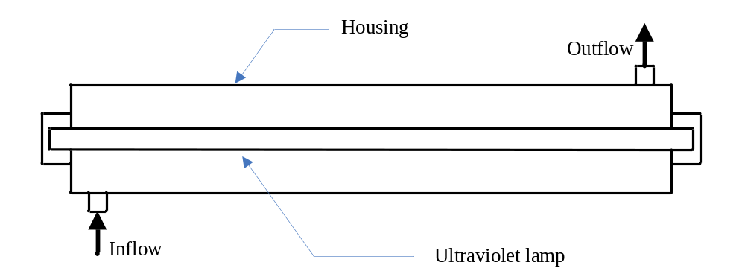

The system is composed of a housing that with a maximum of 120 mm depth around the bulb and the water should have 15 sec. exposure to the UV. Turbidity and color should not exceed 15mg/L. No taste or odor is emitted from UV and there is no danger of overdose.
No residual exists in UV disinfection. It is advisable to use the system at the point of use.
The faster the water is passed through, the longer the tube should be to give 15 seconds exposure.

Ultrasonic waves:
Sonic waves in the range of 20 to 400 kHz tend to inactivate bacteria and viruses in water. The normal retention period is 60 minutes while a high kill for various organisms could occur in 2 seconds.

Other halogens:
Iodine: persists in water as hypoiodous acid and molecular iodine. Does not react with organic nitrogen compounds to form halogenated hydrocarbons.
Bromine, chlorine dioxide, bromine chloride
With iodine we do not have the problem of trichloramines (hydro carbon) like in chlorine because it doesn’t treat with organic compound.

